LAB # 6
Introduction to Assembly Language & Venus Simulator

Objective:

- Get Familiar with Assembly Language & Venus Simulator

System Module (Software)
- Visual Studio Code

Theoretical Background:

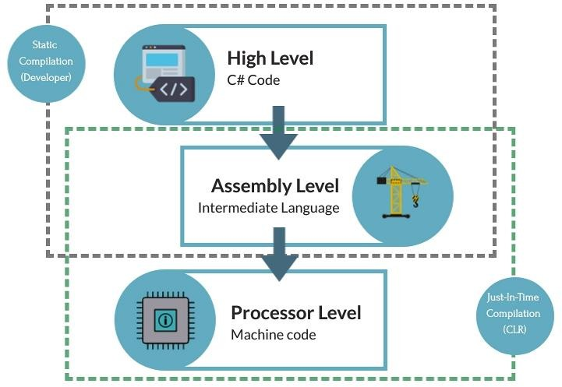
Introduction:

Assembly Language:
Assembly language is the human-readable representation of the computer’s native language. Each assembly language instruction specifies both the operation to perform and the operands on which to operate. We introduce simple arithmetic instructions and show how these operations are written in assembly language. We then define the RISC-V instruction operands: registers, memory, and constants.
High - Level Code | Assembly Code
a = b + c | add a, b, c
a = b - c | sub a, b, c
a = b + c - d | add t, b, c sub a, t, d

Venus:
Venus is an emulator for RISC-V computers. It allows users to run programs written in RISC- V assembly language without having access to a computer running a RISC-V chip.

Registers:
Instructions need to access operands quickly so that they can run fast, but operands stored in memory take a long time to retrieve. Therefore, most architectures specify a small number of registers that hold commonly used operands. The RISC-V architecture has 32 registers, called the register set, stored in a small multi ported memory called a register file. The fewer the registers, the faster they can be accessed.
The figure below shows the 32 registers available in RISC-V Microarchitecture.
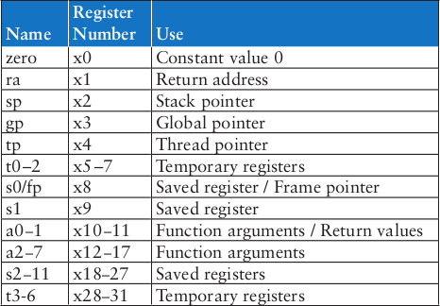
To load a value in a register we can use li command
For example: li s1, 5 loads immediate value 5 in register s1.

High - Level Code | RISC-V Assembly Code
a = b + c | add s0, s1, s2
a = b - c | sub s0, s1, s2
a = b + c - d | add t0, s1, s2 sub s0, t0, s3

Lab Exercise 1:
Translate the Given High Level Code to Assembly Language
High - Level Code | RISC-V Assembly Code
a = b − c;
f = (g + h) − (i + j);

Procedure:

Venus User Interface:
Install extension ‘RISC-V Venus Simulator’ in Visual Studio Code.

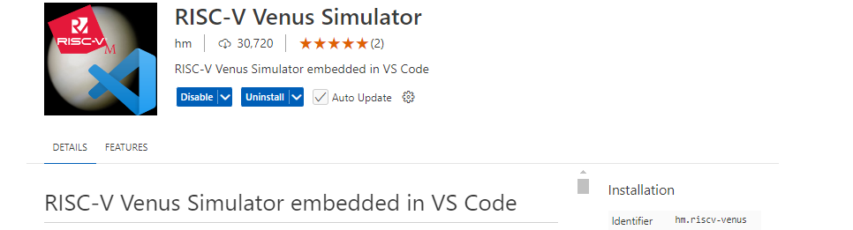
Also install the ‘RISC-V’ Support extension for syntax highlighting.

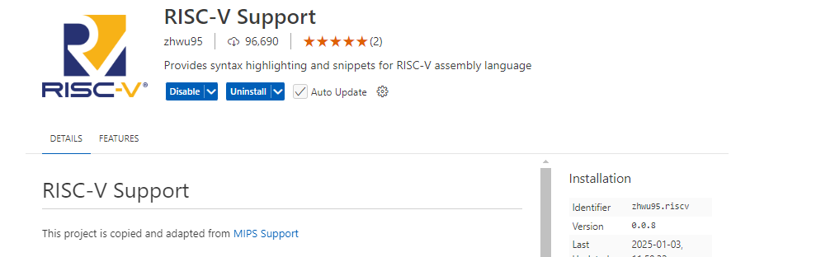
After you have installed extensions, create a folder and add your code files with suitable names using .s extension.

Running a program:
- After writing your assembly code in Editor Tab, click Run and Debug button on left pane. Click on ‘Run and Debug.’
- You’ll see multiple sections to view on left side of the editor window. Drop down Variables > Integer. Here you can view changes in registers when the code runs.
- To run the whole code at once click on Run button at the top.
- To run the code step by step click on the Step Over button. Using this option, you can view changes in Registers and Memory over each step.

In-Lab Tasks:

Convert the given High Level Code on RISC-V Assembly and run it on Venus Simulator.
  - a = a + 4;
b = a − 12;

  - if (g < h) g = g + 1; else
h = h − 1;
Hint: Use branch instruction.

Post-Lab Tasks:

- Write down a simple C/C++/Java/Python program to add, subtract, multiply and divide two integer numbers. Convert your code into assembly code and simulate it on Venus.

- Write a code in assembly using RISC-V to find out the average of five numbers stored in saved registers s3 to s7. Store the mean in s0.

Learning Outcomes:

Upon successful completion of the lab, students will be able to: LO1: Run the basic assembly code on Venus Simulator.

